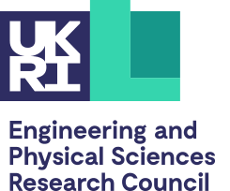
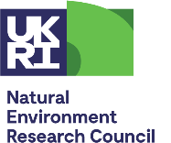
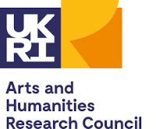
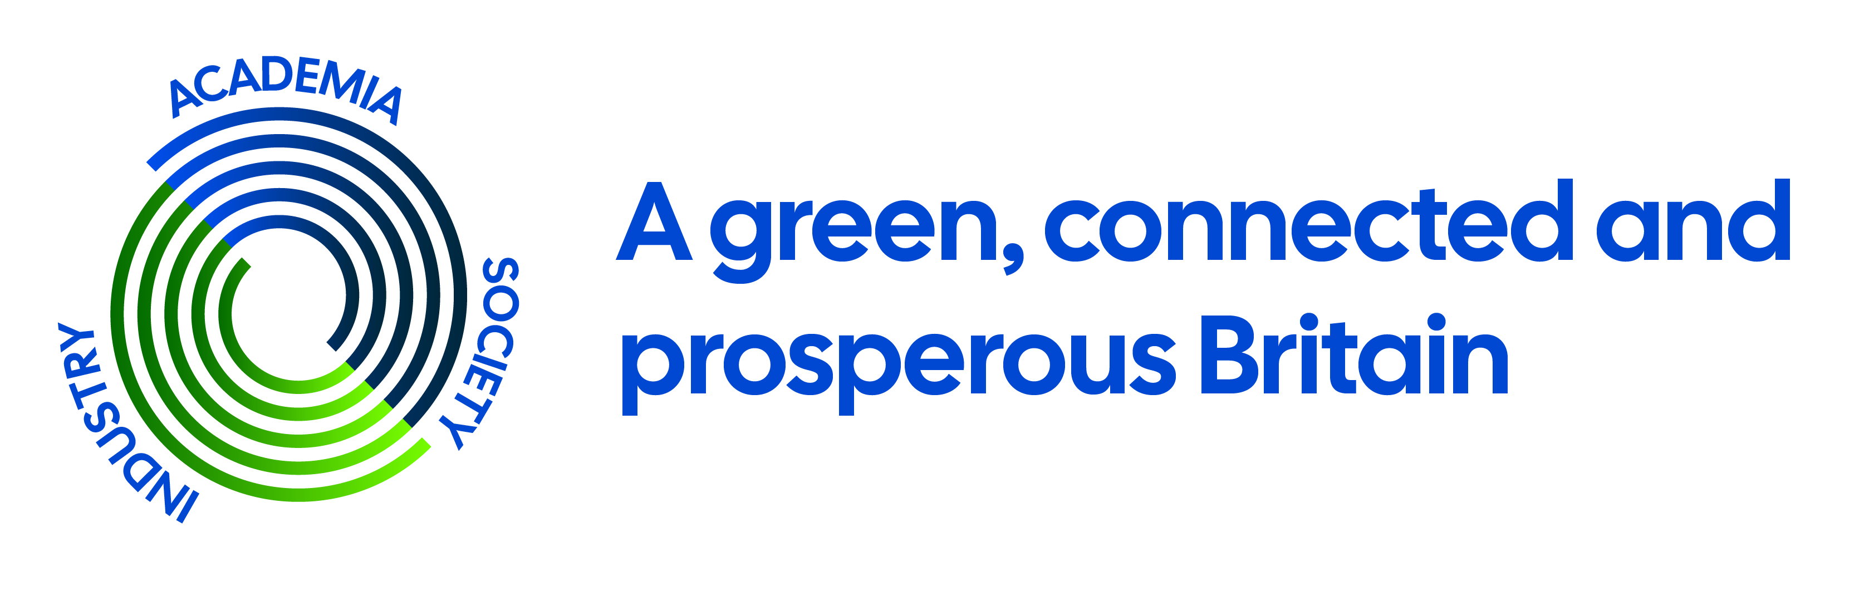

UKRI NetworkPlus: A Green, Connected and Prosperous Britain (GCPB) N⁺
Phase One - CALL FOR PROPOSALS

Title: Call for Feasibility Studies from the UKRI GPCB N⁺ in 5G (and beyond) and applications for resilient, flexible Renewable Energy Systems. Closing date: Friday 12th of August 2022, 5 pm

RESEARCH AND FEASIBILITY STUDIES: Two Part Application form
Call closes: Friday 12th of August 2022, 5 pm
Please email completed forms to mailto:contact@greenconnectedbritain.org
Please complete all forms in font type- Century Gothic 10

Part TWO
Case for Support
Proposal can be a maximum of up to 4 pages. Figures (up to 4) and references can be provided as an appendix.

Project title
Project start date (approx.)
Project duration (weeks)

Context (400 words)

Aims and objectives (400 words)

Benefits of the proposed work (400 words)

A statement of the novelty of the proposed work (400 words)

Costings (How will the funding be spent and when)

Details of the proposed work and research methodology (800 words)

Outline project plan and deliverables (500 words)

Current funding available, if any
Other funding currently available for this project: How much and for what duration?

Future funding Aspirations
How could further funding in this area be obtained? (400 words)

