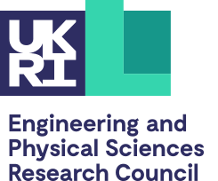
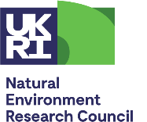
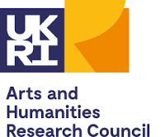
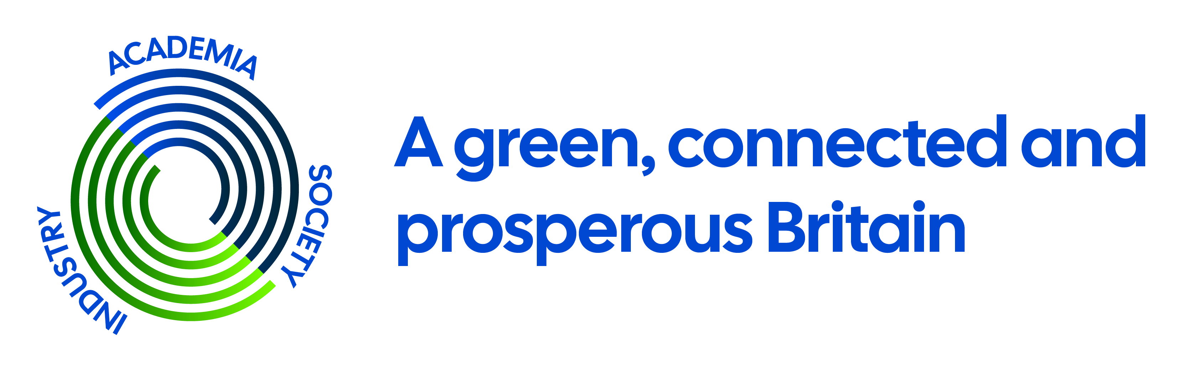

UKRI NetworkPlus: A Green, Connected and Prosperous Britain (GCPB) N⁺
Phase One - CALL FOR PROPOSALS

Title: Call for Feasibility Studies from the UKRI GPCB N⁺ in 5G (and beyond) and applications for resilient, flexible Renewable Energy Systems. Closing date: Friday 12th of August 2022, 5 pm

RESEARCH AND FEASIBILITY STUDIES: Two Part Application form
Call closes: Friday 12th of August 2022, 5 pm
Please email completed forms to mailto:contact@greenconnectedbritain.org
Please complete all forms in font type- Century Gothic 10

Part ONE

Project title
Project start date (approx.)
Project duration (weeks)
Lead organisation
Principal investigator
Address
Telephone
Email

Project team (including industry partner(s))
Please indicate early career researchers by mentioning ECR in brackets after their names.
Max 400 words

Brief track record in the context of the proposal
Max 400 words

